Lesson plan
Teaching forward rolling and backward rolling
Age of class: Upper Juniors (10 to 12 years).
Present Ability of Class: The class was at an advanced stage and individuals had no problems participating.
Considerations needed to be given to the following:
The time available: 40 minutes
The apparatus available: We had a selection of apparatus from the store room but what were needed for this lesson plan were gymnastic mats.
The physical limitations of the hall: The hall was halved using nets. We had a well spread out area and space was not limited.
The number of children in the class: 20
The teachers own training and experience: We had experience from previous teaching of gymnastics to students.
The time taking up by changing: There was no time taking up from changing clothes as the children had already come in there P.E gear.
The kit the children are expected to wear: The kit that the children were expected to wear were clothes that they have for leisure wear such as they’re P.E kit such as Tracksuit bottoms and T-shirt also as we are teaching gymnastics this would make it more comfortable to carry out gymnastic movements, the children were expected to take off they’re shoes.
The apparatus to be used: The apparatus that we used to teach the forward roll and backward roll was gymnastic mats.
Lesson Theme: The theme of the lesson plan is the forward roll and back roll. I’m going to go step by step the correct way to perfect the forward roll and backward rolls and also the teaching points.
Opening activity: Again the activity that was used for the opening was dance and movement to music of our choice. This opening activity was used for the warm up. The idea of the opening activity was to get the heart rate going and it was also a fun way for the kids to warm up as running and drills are repetitive and kids lose interest. During the song the leader called out different movements and dances and the children followed and they looked to enjoy themselves. When the song was over the kids were split into different groups and were thought different gymnastic skills.

Floor work (a. Use of body; b. Use of legs; c. Use of arm.)
The floor work was teaching the children the gymnastic skill of forward rolling and backward rolling. The following teaching points were used to teach the children.

- Squat down with your legs and feet together.

- Bend your arms and place your hands right next to your ears with your palms flat on the floor or mat with fingers facing forward.

- Tuck your chin into your chest.

- Round your back like a cat.

- Lean frontwards and roll forward.

- For the more advanced children they can forward roll into a standing position. For example, When your feet meet the ground straighten your legs and push off the floor into a standing or squat position.

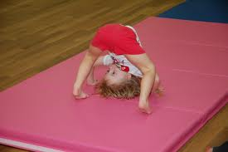
Body Positioning for the forward roll

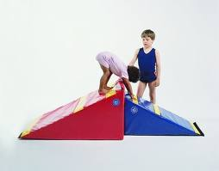

Apparatus like the one in the picture above is also a good way of teaching the forward roll.
Teaching the back roll:

Teaching points:
1. Squat down with your legs and feet together.
2. Bend your arms and place your hands right next to your ears with your palms facing the ceiling and your fingers facing backwards.
3. Tuck your chin to your chest
4. Round your back like a cat
5. Lean backwards and roll
6. Once your hands meet the ground make your arms are straight and push off the floor.
7. Land on your feet in either a pike or a squat (do not land on your knees)
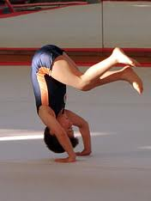
Body positioning for the backward roll

Apparatus Work: The apparatus that we used was gymnastic mats. We did not use the inclined apparatus as we felt it may be too dangerous to us and an injury could occur as we did not have enough spotters.

