Lesson plan
Teaching the headstand
Age of class: Upper Juniors (10 to 12 years).
Present Ability of Class: The class was at an advanced stage and individuals had no problems participating.
Considerations needed to be given to the following:
The time available: 40 minutes
The apparatus available: We had a selection of apparatus from the store room but what were needed for this lesson plan were gymnastic mats.
The physical limitations of the hall: The hall was halved using nets. We had a well spread out area and space was not limited.
The number of children in the class: 20
The teachers own training and experience: We had experience from previous teaching of gymnastics to students.
The time taking up by changing: There was no time taking up from changing clothes as the children had already come in there P.E gear.
The kit the children are expected to wear: The kit that the children were expected to wear were clothes that they have for leisure wear such as they’re P.E kit such as Tracksuit bottoms and T-shirt also as we are teaching gymnastics, the children were expected to take off they’re shoes.
The apparatus to be used: The apparatus that we used to teach the headstand was gymnastic mats. Also props could be used for the headstand for children finding it hard to do the headstand on their own. Another way would be the use of the wall for support.

Lesson Theme: The theme of the lesson plan is headstand. I’m going to go step by step the correct way to perfect the headstand and also the teaching points.
Opening activity: The activity that was used for the opening was dance and movement to music of our choice. This opening activity was used for the warm up. The idea of the opening activity was to get the heart rate going and it was also a fun way for the kids to warm up as running and drills are repetitive and kids lose interest. During the song the leader called out different movements and dances and the children followed and they looked to enjoy themselves. When the song was over the kids were split into different groups and were thought different gymnastic skills.
Floor work (a. Use of body; b. Use of legs; c. Use of arm.)
The floor work was teaching the children the gymnastic skill of the headstand. The following teaching points were used to teach the children.
- The first position taught is the tripod.
- The child kneels or squats on the mat and places hands about shoulder width or slightly wider, with fingers pointing forward with the head slightly behind the hands.
- Hands and the top of the head should form a triangle shape.
- After placing hands and head on mat, each knee is rested on its both elbows. As shown in the picture below.
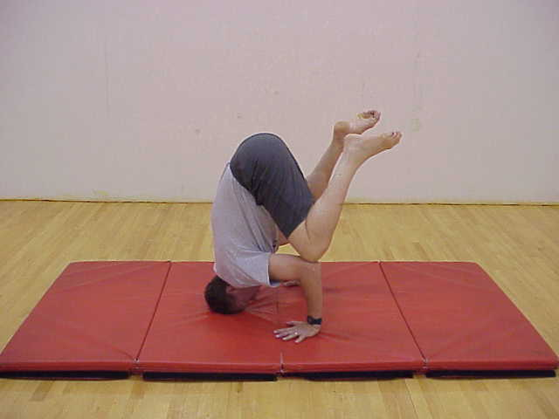
Tripod Position
- The next teaching position is the Half Headstand. The children get back into tripod position and then lifts the knees off the elbows until the thighs are horizontal. As shown in the picture below.
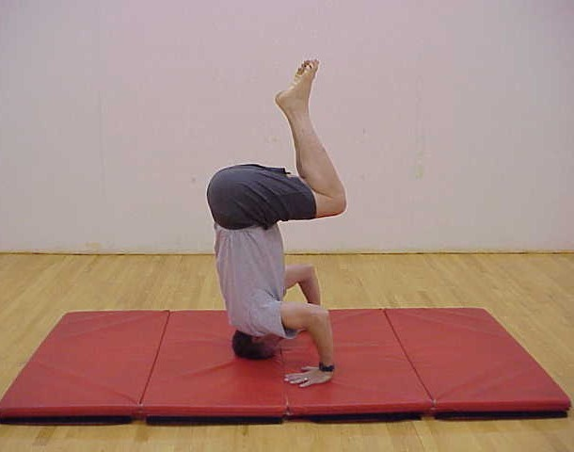
Half Headstand
- Finally the last step to the headstand is the full headstand which involves extending the legs out fully towards the ceiling in a vertical position. This is the completion of the full headstand below.

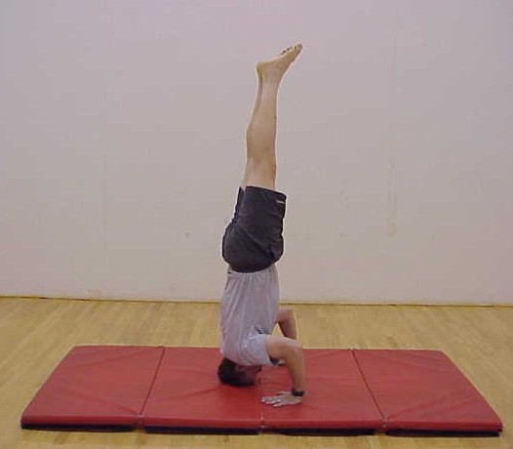
Full Headstand

Apparatus work:
The apparatus work we used was gymnastic equipment which was different shapes and slotted in together. They were used for the children to use them as support and it was a variation for the children who weren’t as confident as others. Also the use of the walls was used for support and this was also another variation.

The use of space: The space was used up and the children were spread across the floor area with mats and props.
Use of apparatus: Props were used to support the children whilst doing the headstand until they were confident of doing it without the apparatus.
Movement tasks: The children had to use different movement types to perfect the headstand.

